South Carolina Association of Prevention Professionals and Advocates
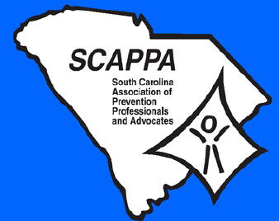

Annual Membership Meeting & Training

Prevention Through the Decades…….
70’s, 80’s, 90’s, 2000’s

December 6, 2013 9:00 am – 4:00 pm Brookland Baptist
(9 am – 9:30 am – Registration)

Brookland Baptist Church - Administration Building
1066 Sunset Blvd.
West Columbia, SC 29169

9:00 am- 9:30 am Registration

9:30 am – 11:45 am Welcome/SCAPPA Business

- Annual Report
- Certification Report
- Recognition of New Certified Members
- Introduction of the SCAPPA Board
- SCAPPA Awards

11:45 am – 12:00 pm Presentation of Fundraising Baskets

12:00 pm – 1:00 pm Lunch

1:00 pm – 3:15 pm Training

3:15 pm – 3:45 pm Jan Oglietti Fundraiser
3:45 pm – 4:00 pm Evaluations, Certificates & Adjournment

Prevention Through the Decades: Strategies to Reduce Substance Abuse
70’S, 80’S, 90’s, 2000’S AND NOW?

Celebrate the decades of difference—four decades that have made a positive difference in the substance abuse prevention field. Experts in the field of prevention (past and present) will highlight the milestones in substance abuse prevention over the last four decades. We will hear from an all-star panel as they discuss prevention strategies used in the 70’s, 80’s, 90’s through 2012- that have improved outcomes and saved lives.
Objective:
Strategies to Reduce Substance Abuse is an assessment of strategies used in communities in South Carolina to reduce alcohol, tobacco and drug use and abuse. The workshop is intended to identify these strategies with examples of programs that are making a difference. Identifying risk and protective factors and focusing on the resiliency and strengths of youths and adults, for example, have become major focuses of prevention programs.

The speakers will focus on five prevention strategies:
- Teaching prevention in schools
- Reaching youths outside school
- Targeting high-risk groups
- Engaging Parents
- Empowering communities
The growing emphasis on “what works” among funders requires that communities learn from each other and implement program models with a track record of success. Using programs that are effective in other communities, tailoring those programs to the needs of the specific locality, and evaluating their success is critical to creating a sustainable approach (U.S. Dept. of Justice, 2000).

http://www.scappaonline.org/

https://www.facebook.com/pages/South-Carolina-Association-for-Prevention-Professionals-Advocates/

